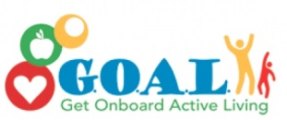

School and Home Connection

[](http://www.google.com/url?sa=i&rct=j&q=&esrc=s&source=images&cd=&cad=rja&uact=8&ved=0ahUKEwjwlu6K8frMAhVHb1IKHe1uCK4QjRwIBw&url=http://worldartsme.com/moment/?order%3Ddownloads&bvm=bv.122676328,d.aXo&psig=AFQjCNFKNLsr0aSGwZB9pKK41gUZlY4CfA&ust=1464460025220462)

**What are we learning about this week?**

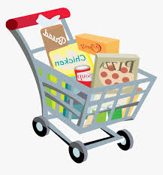This week we learned about **grocery stores** and some healthy strategies for grocery shopping.

[](http://www.google.com/url?sa=i&rct=j&q=&esrc=s&source=images&cd=&cad=rja&uact=8&ved=0ahUKEwjQ68WK8PrMAhUDRVIKHYOsCO4QjRwIBw&url=http://www.iconsdb.com/green-icons/checked-checkbox-icon.html&psig=AFQjCNGx274qGm6OHn9EC_n7HPDyelDDmg&ust=1464459811754645)

**What is this week’s goal?**

Be active for 60 minutes every day!



**Review with your child:**

1. What is one helpful tip for grocery shopping? (Shop along the outside edges of the store, make a list, read food labels, don’t shop hungry, etc.)
2. [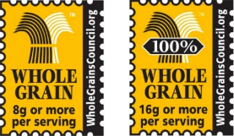](http://www.google.com/url?sa=i&rct=j&q=&esrc=s&source=images&cd=&cad=rja&uact=8&ved=0ahUKEwjtudeQjPvMAhVIRFIKHcixDKUQjRwIBw&url=http://www.studentpulse.com/articles/965/2/important-distinctions-between-labels-and-certifications-and-why-they-matter&bvm=bv.122676328,d.aXo&psig=AFQjCNEqvTxjICwdYDRhIiJ8SYrWmwhinQ&ust=1464467325736149)What is something you can look for in the produce section of the store? (All of the different colors!)
3. How can you tell if a grain food is a whole grain? (Look for the whole grain stamp picture or the first word as “whole” in the ingredient list)

[](http://www.google.com/url?sa=i&rct=j&q=&esrc=s&source=images&cd=&ved=2ahUKEwiz3IKgrNzfAhWJq4MKHYaEBkwQjRx6BAgBEAU&url=http://www.clipartpanda.com/categories/happy-person-clipart&psig=AOvVaw0dJZAuGmxpE7GoXtKP6QbF&ust=1546973690666896)

**Take action:**

If possible, take your child to pick up food with you this week and ask them to teach you one new thing they learned during their GOAL lesson!