

School and Home Connection

[](http://www.google.com/url?sa=i&rct=j&q=&esrc=s&source=images&cd=&cad=rja&uact=8&ved=0ahUKEwjwlu6K8frMAhVHb1IKHe1uCK4QjRwIBw&url=http://worldartsme.com/moment/?order%3Ddownloads&bvm=bv.122676328,d.aXo&psig=AFQjCNFKNLsr0aSGwZB9pKK41gUZlY4CfA&ust=1464460025220462)

**What are we learning about this week?**

This week we learned about **fruits and vegetables** and why it is important to eat them every day. We also learned about the many different **benefits of physical activity!**

[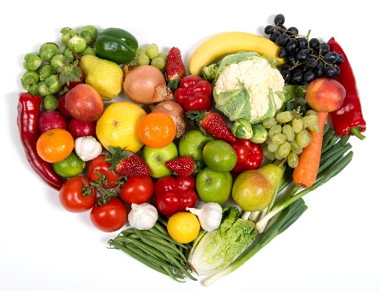](http://www.google.com/url?sa=i&rct=j&q=&esrc=s&source=images&cd=&cad=rja&uact=8&ved=2ahUKEwiaiYTQ1uPfAhVL34MKHdQ5D_gQjRx6BAgBEAU&url=http://www.newfoundbalance.com/fruits-and-vegetables-getting-to-the-root-of-the-problem/&psig=AOvVaw1JlxR68XyQFi9HxW49FDAX&ust=1547225585745073)[](http://www.google.com/url?sa=i&rct=j&q=&esrc=s&source=images&cd=&cad=rja&uact=8&ved=0ahUKEwjQ68WK8PrMAhUDRVIKHYOsCO4QjRwIBw&url=http://www.iconsdb.com/green-icons/checked-checkbox-icon.html&psig=AFQjCNGx274qGm6OHn9EC_n7HPDyelDDmg&ust=1464459811754645)

**What is this week’s goal?**

Eat at least 1 fruit and 1 vegetable every day this week. The more, the better!



**Review with your child:**

1. How many servings of fruits and vegetables should we eat every day? (5)
2. What are some of your favorite fruits and vegetables? What’s your favorite way to eat them?
3. What is your favorite part about being active?

[](http://www.google.com/url?sa=i&rct=j&q=&esrc=s&source=images&cd=&ved=2ahUKEwiz3IKgrNzfAhWJq4MKHYaEBkwQjRx6BAgBEAU&url=http://www.clipartpanda.com/categories/happy-person-clipart&psig=AOvVaw0dJZAuGmxpE7GoXtKP6QbF&ust=1546973690666896)

**Take action:**

Try adding one extra fruit or vegetable to your normal meals each day! This could be adding some spinach or pineapple to a smoothie or adding some extra veggies on top of a pizza!