

School and Home Connection

[](http://www.google.com/url?sa=i&rct=j&q=&esrc=s&source=images&cd=&cad=rja&uact=8&ved=0ahUKEwjwlu6K8frMAhVHb1IKHe1uCK4QjRwIBw&url=http://worldartsme.com/moment/?order%3Ddownloads&bvm=bv.122676328,d.aXo&psig=AFQjCNFKNLsr0aSGwZB9pKK41gUZlY4CfA&ust=1464460025220462)

**What are we learning about this week?**

This week we learned about why it is important to eat a **rainbow** of fruits and vegetables. We also learned about **reducing screen time** and adding more active time to the day.

[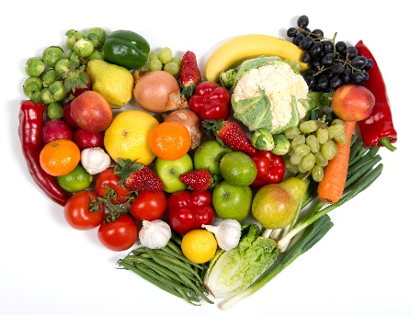](http://www.google.com/url?sa=i&rct=j&q=&esrc=s&source=images&cd=&cad=rja&uact=8&ved=2ahUKEwiaiYTQ1uPfAhVL34MKHdQ5D_gQjRx6BAgBEAU&url=http://www.newfoundbalance.com/fruits-and-vegetables-getting-to-the-root-of-the-problem/&psig=AOvVaw1JlxR68XyQFi9HxW49FDAX&ust=1547225585745073)[](http://www.google.com/url?sa=i&rct=j&q=&esrc=s&source=images&cd=&cad=rja&uact=8&ved=0ahUKEwjQ68WK8PrMAhUDRVIKHYOsCO4QjRwIBw&url=http://www.iconsdb.com/green-icons/checked-checkbox-icon.html&psig=AFQjCNGx274qGm6OHn9EC_n7HPDyelDDmg&ust=1464459811754645)

**What is this week’s goal?**

Choose one activity to do each day this week that doesn’t involve a screen!



**Review with your child:**

1. Why is it important to eat a rainbow of fruits and vegetables? (They all have different vitamins and help our bodies in different ways)
2. Name a fruit or vegetable of every color!
3. What is the recommended limit for screen time in your free time every day? (2 hours)
4. Name 3 things you like to do that don’t involve a screen!

[](http://www.google.com/url?sa=i&rct=j&q=&esrc=s&source=images&cd=&ved=2ahUKEwiz3IKgrNzfAhWJq4MKHYaEBkwQjRx6BAgBEAU&url=http://www.clipartpanda.com/categories/happy-person-clipart&psig=AOvVaw0dJZAuGmxpE7GoXtKP6QbF&ust=1546973690666896)

**Take action:**

Try making a list of all activities you like to do that don’t involve a screen. You can make lists as individuals or together as a family. When someone is feeling bored or not sure what they want to do, refer to the list and choose an activity!