

School and Home Connection

[](http://www.google.com/url?sa=i&rct=j&q=&esrc=s&source=images&cd=&cad=rja&uact=8&ved=0ahUKEwjwlu6K8frMAhVHb1IKHe1uCK4QjRwIBw&url=http://worldartsme.com/moment/?order%3Ddownloads&bvm=bv.122676328,d.aXo&psig=AFQjCNFKNLsr0aSGwZB9pKK41gUZlY4CfA&ust=1464460025220462)

**What are we learning about this week?**

This week we learned about **whole grains** and why they are important to our health. We also reviewed everything we’ve learned so far about **physical activity**!

[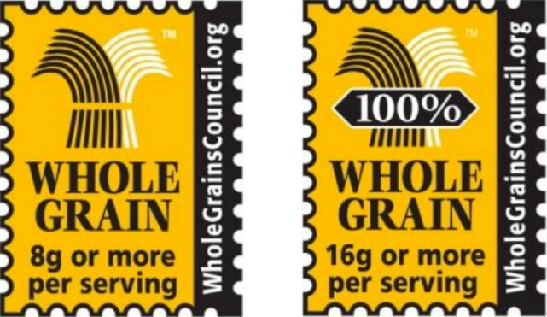](http://www.google.com/url?sa=i&rct=j&q=&esrc=s&source=images&cd=&cad=rja&uact=8&ved=0ahUKEwjtudeQjPvMAhVIRFIKHcixDKUQjRwIBw&url=http://www.studentpulse.com/articles/965/2/important-distinctions-between-labels-and-certifications-and-why-they-matter&bvm=bv.122676328,d.aXo&psig=AFQjCNEqvTxjICwdYDRhIiJ8SYrWmwhinQ&ust=1464467325736149)[](http://www.google.com/url?sa=i&rct=j&q=&esrc=s&source=images&cd=&cad=rja&uact=8&ved=0ahUKEwjQ68WK8PrMAhUDRVIKHYOsCO4QjRwIBw&url=http://www.iconsdb.com/green-icons/checked-checkbox-icon.html&psig=AFQjCNGx274qGm6OHn9EC_n7HPDyelDDmg&ust=1464459811754645)

**What is this week’s goal?**

Find a grain food at home or at the grocery store. Look at the label and decide whether or not it is a whole grain.



**Review with your child:**

1. What is a food that goes in the Grain category of MyPlate? (Bread, cereal, rice, pasta, etc.)
2. How do you know if a grain food is a whole grain? What can you look for on the package? (The picture above, the first word of the ingredient list is whole)
3. How many minutes of physical activity should we try to get every day? (60)

[](http://www.google.com/url?sa=i&rct=j&q=&esrc=s&source=images&cd=&ved=2ahUKEwiz3IKgrNzfAhWJq4MKHYaEBkwQjRx6BAgBEAU&url=http://www.clipartpanda.com/categories/happy-person-clipart&psig=AOvVaw0dJZAuGmxpE7GoXtKP6QbF&ust=1546973690666896)

**Take action:**

Try substituting one whole grain food in place of one of the grain foods in your house! This could be whole wheat bread, frozen waffles, pasta, brown rice, or even whole wheat flour for baking!

To determine if a grain food is a whole grain food, check the ingredients list. If the first word is **whole**, it’s a whole grain!