

School and Home Connection

[](http://www.google.com/url?sa=i&rct=j&q=&esrc=s&source=images&cd=&cad=rja&uact=8&ved=0ahUKEwjwlu6K8frMAhVHb1IKHe1uCK4QjRwIBw&url=http://worldartsme.com/moment/?order%3Ddownloads&bvm=bv.122676328,d.aXo&psig=AFQjCNFKNLsr0aSGwZB9pKK41gUZlY4CfA&ust=1464460025220462)

**What are we learning about this week?**

This week we learned more about **drink choices** and ways we can choose more “Go” drinks. We also learned about the benefits of participating in **team sports and games.**

[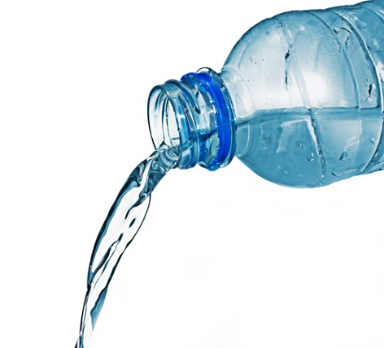](http://www.google.com/url?sa=i&rct=j&q=&esrc=s&source=images&cd=&cad=rja&uact=8&ved=0ahUKEwiox8nhjPvMAhUJK1IKHXZHB04QjRwIBw&url=http://www.quickanddirtytips.com/relationships/dining-travel/proper-way-refill-water-bottle&bvm=bv.122676328,d.aXo&psig=AFQjCNHRQ-8ZrW-TUoVgoI19kYsLy425PA&ust=1464467481315909)[](http://www.google.com/url?sa=i&rct=j&q=&esrc=s&source=images&cd=&cad=rja&uact=8&ved=0ahUKEwjQ68WK8PrMAhUDRVIKHYOsCO4QjRwIBw&url=http://www.iconsdb.com/green-icons/checked-checkbox-icon.html&psig=AFQjCNGx274qGm6OHn9EC_n7HPDyelDDmg&ust=1464459811754645)

**What is this week’s goal?**

Drink 6 cups (or 3 bottles) of water or other Go drinks every day this week.



**Review with your child:**

1. What is a Go drink? What is an example of one that you like to drink? (Drinks that it’s great to have all the time. Water, skim or 1% milk, flavored waters or sports drink with zero sugar)
2. What is one thing you like about playing a game or sport with other kids?
3. What has been your favorite game you’ve played in GOAL?

[](http://www.google.com/url?sa=i&rct=j&q=&esrc=s&source=images&cd=&ved=2ahUKEwiz3IKgrNzfAhWJq4MKHYaEBkwQjRx6BAgBEAU&url=http://www.clipartpanda.com/categories/happy-person-clipart&psig=AOvVaw0dJZAuGmxpE7GoXtKP6QbF&ust=1546973690666896)

**Take action:**

As a family, try to drink an extra glass of water every day this week! You can drink it in the morning, before dinner, or any other time that you can set to help you remember. Mio and Crystal Light flavor packets are a great addition if the taste of plain water really isn’t your thing!