

School and Home Connection

[](http://www.google.com/url?sa=i&rct=j&q=&esrc=s&source=images&cd=&cad=rja&uact=8&ved=0ahUKEwjwlu6K8frMAhVHb1IKHe1uCK4QjRwIBw&url=http://worldartsme.com/moment/?order%3Ddownloads&bvm=bv.122676328,d.aXo&psig=AFQjCNFKNLsr0aSGwZB9pKK41gUZlY4CfA&ust=1464460025220462)

**What are we learning about this week?**

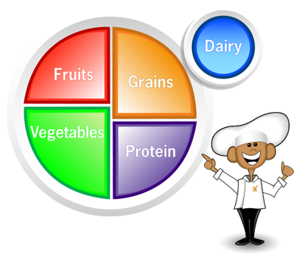This week we learned about **MyPlate** and how it can help us make healthy choices at mealtime. We also learned that we should all be active for at least **60 minutes** every day!

[](http://www.google.com/url?sa=i&rct=j&q=&esrc=s&source=images&cd=&cad=rja&uact=8&ved=0ahUKEwjQ68WK8PrMAhUDRVIKHYOsCO4QjRwIBw&url=http://www.iconsdb.com/green-icons/checked-checkbox-icon.html&psig=AFQjCNGx274qGm6OHn9EC_n7HPDyelDDmg&ust=1464459811754645)

**What is this week’s goal?**

Try a new active game at school or home.



**Review with your child:**

1. What is MyPlate? (A guide that shows us how to build balanced meals)
2. What is an example of one food from each food group?
3. How many minutes should we be active every day? (60)
4. What kinds of physical activities do you like to do?

[](http://www.google.com/url?sa=i&rct=j&q=&esrc=s&source=images&cd=&ved=2ahUKEwiz3IKgrNzfAhWJq4MKHYaEBkwQjRx6BAgBEAU&url=http://www.clipartpanda.com/categories/happy-person-clipart&psig=AOvVaw0dJZAuGmxpE7GoXtKP6QbF&ust=1546973690666896)

**Take action:**

Try to set aside some time one day this week to do something active together as a family.