

School and Home Connection

[](http://www.google.com/url?sa=i&rct=j&q=&esrc=s&source=images&cd=&cad=rja&uact=8&ved=0ahUKEwjwlu6K8frMAhVHb1IKHe1uCK4QjRwIBw&url=http://worldartsme.com/moment/?order%3Ddownloads&bvm=bv.122676328,d.aXo&psig=AFQjCNFKNLsr0aSGwZB9pKK41gUZlY4CfA&ust=1464460025220462)

**What are we learning about this week?**

This week we learned about **drinks** and ways we can choose lower-sugar drinks that we enjoy. We also learned about **pedometers** and how many steps we can try to take in a day!

[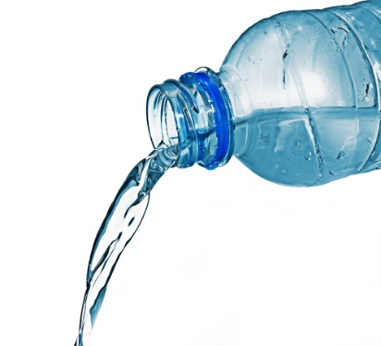](http://www.google.com/url?sa=i&rct=j&q=&esrc=s&source=images&cd=&cad=rja&uact=8&ved=0ahUKEwiox8nhjPvMAhUJK1IKHXZHB04QjRwIBw&url=http://www.quickanddirtytips.com/relationships/dining-travel/proper-way-refill-water-bottle&bvm=bv.122676328,d.aXo&psig=AFQjCNHRQ-8ZrW-TUoVgoI19kYsLy425PA&ust=1464467481315909)[](http://www.google.com/url?sa=i&rct=j&q=&esrc=s&source=images&cd=&cad=rja&uact=8&ved=0ahUKEwjQ68WK8PrMAhUDRVIKHYOsCO4QjRwIBw&url=http://www.iconsdb.com/green-icons/checked-checkbox-icon.html&psig=AFQjCNGx274qGm6OHn9EC_n7HPDyelDDmg&ust=1464459811754645)

**What is this week’s goal?**

Wear your pedometer every day this week! Check it at the end of each day to see how many steps you got.



**Review with your child:**

1. When choosing something to drink, what is something we should look for on the label to see how much it has? (Sugar)
2. What is a low-sugar drink that you like? (Water, some flavored waters, milk, Gatorade/Powerade Zero)
3. How many steps do we want to try to take every day? (10,000)
4. What’s one way we could take more steps in the day?

[](http://www.google.com/url?sa=i&rct=j&q=&esrc=s&source=images&cd=&ved=2ahUKEwiz3IKgrNzfAhWJq4MKHYaEBkwQjRx6BAgBEAU&url=http://www.clipartpanda.com/categories/happy-person-clipart&psig=AOvVaw0dJZAuGmxpE7GoXtKP6QbF&ust=1546973690666896)

**Take action:**

As a family, try to drink an extra glass of water every day this week! You can drink it in the morning, before dinner, or any other time that you can set to help you remember. Mio and Crystal Light flavor packets are a great addition if the taste of plain water really isn’t your thing!